In this lab, you will add responsive images to the Egypt vacation webpage as shown below.

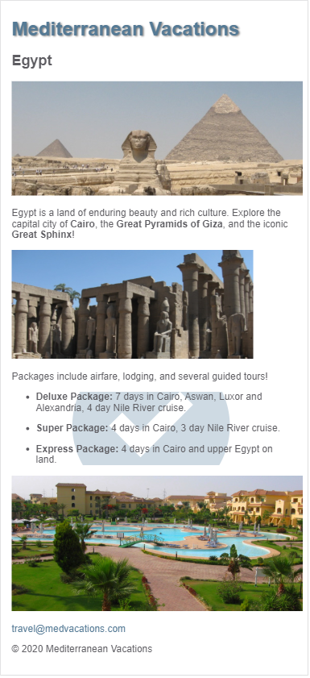

# Different resolutions for different DPRs

Modify the first <img> in egypt.html to use the srcset attribute. Show egypt_600.jpg on a 1 DPR screen, egypt_1200.jpg on a 2 DPR screen, and egypt_1800.jpg on a 3 DPR screen.

The Chrome DevTools' Network tab can be used to verify that the appropriate image is requested depending on the DPR. Ex: The screenshot below shows egypt_1200.jpg is requested when the DPR is 2.0.

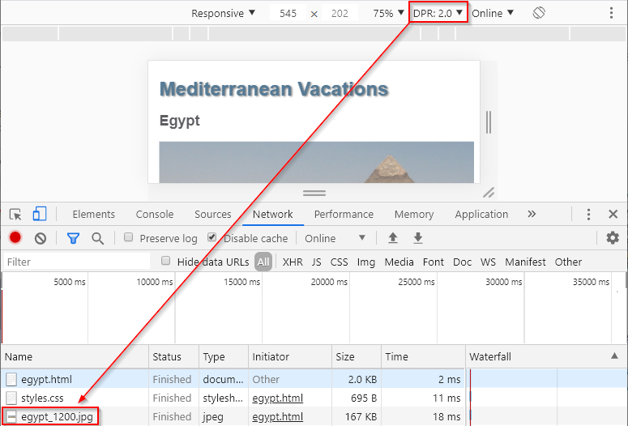

# Different image sizes for different viewport widths

Modify the second <img> in egypt.html to use the srcset and sizes attributes.

**Hints: (Refer only if required)**

The srcset attribute should indicate the image names and associated sizes:

* luxor_600.jpg is 600 pixels wide
* luxor_800.jpg is 800 pixels wide
* luxor_1200.jpg is 1200 pixels wide

The sizes attribute should describe the image size requirements for various viewport widths:

* When the viewport width is at least 700px wide, the image width should be 600px.
* When the viewport width is at least 500px wide, the image width should be 400px.
* The default image width should be 200px.

Resizing the browser width should cause the three different images to display at the 500 and 700 breakpoints.

# Art direction for different viewport widths

Add <picture> tags around the third <img> in egypt.html. Then add the appropriate tag inside <picture> so hotel_wide.jpg is displayed instead of hotel_narrow.jpg when the viewport width is at least 500px wide.

Resizing the browser should display hotel_narrow.jpg when the viewport width is < 500px wide and hotel_wide.jpg otherwise.

# SVG image for list background

Modify styles.css so check.svg is displayed centered in the background of the unordered list. Set the following CSS properties:

**Hints: (Refer only if required)**

* background-image should display check.svg
* background-repeat should be no-repeat
* background-position should be center
* background-size should be 60vw

Resizing the browser width should cause the check.svg image to grow and shrink.